Problem Definition:

Need to build a model that can predict whether the loan of the applicant will be approved (Loan status) or not on the basis of the details provided in the dataset.

Data Analysis:

* In this project we are going to classify whether the applicant can get approval of loan or not on the basis of applicant’s Income, Education, Property area and many more other factors.
* First we need to import necessary libraries like numpy, seaborn, matplotlib etc.
* Load the data into pandas data frame. and collecting data from the following link.

df=pd.read_csv('https://raw.githubusercontent.com/dsrscienti st/DSData/refs/heads/master/loan_prediction.csv')

* Using df.head() we can see the top 5 records of dataset.

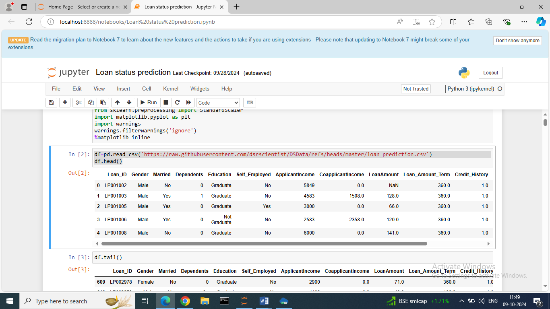

* first we need to do data analysis means need to check what type of data are contained in our dataset, checking the Total number of rows and columns, is any missing values, duplicate values.

1. checking total no. of rows and columns:

df.shape

(614,13) 🡪 So, this dataset contains total 614 rows and 13 columns.

1. Checking the information of dataset.

df.info ()

In this dataset 3 types of data are present float64, int64 and object with memory usage.

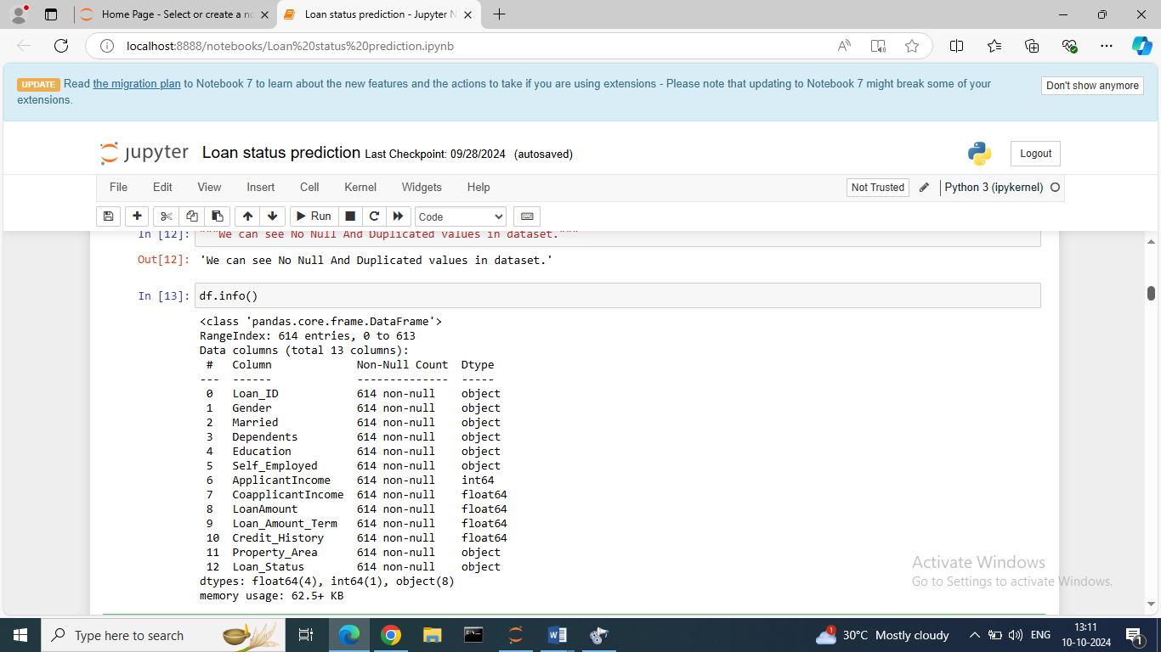

1. Checking any Null values are present in Dataset or Not.

df.isnull().sum()

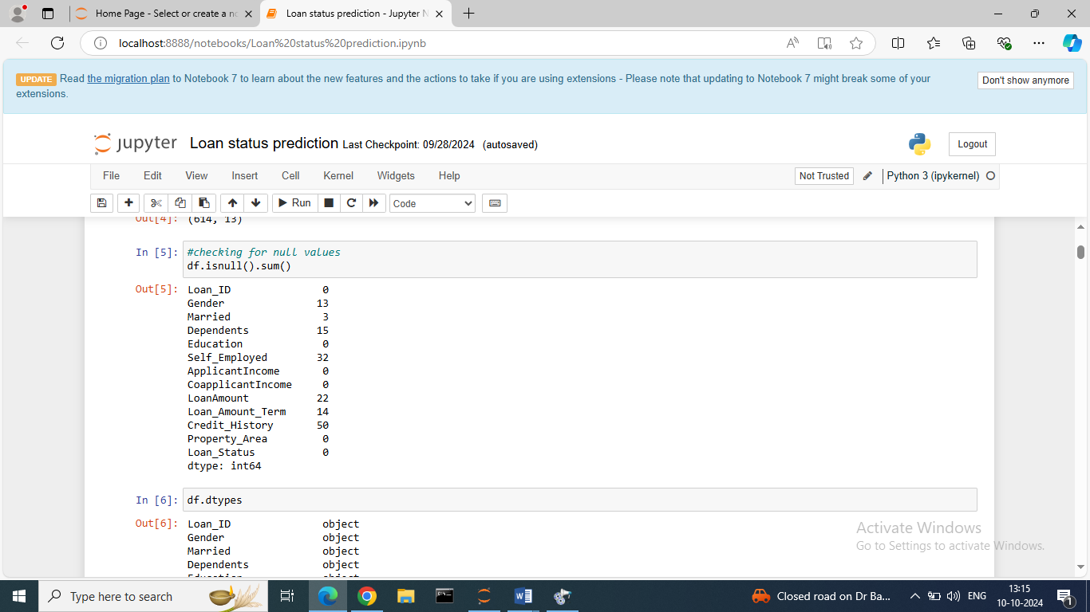

So, in our dataset the feature Gender, Married, Dependents, Self Employed, Loan Amount, Loan amount term, Credit History having null values.

* The feature Gender, Married, Dependents and Self Employed are categorical therefore using Mode method we removing null values.
* And the feature Loan amount, Loan amount term and credit history are in continuous nature therefore using mean method we removing null values.

1. Checking duplicated values.

df.duplicated().sum()

-No duplicate values present in dataset.

Exploratory Data Analysis (EDA):

We done with Data analysis now we do the exploratory data analysis means need to check the Statistical Summary of dataset, Data visualization etc.

* Checking the Statistical Summary of Dataset

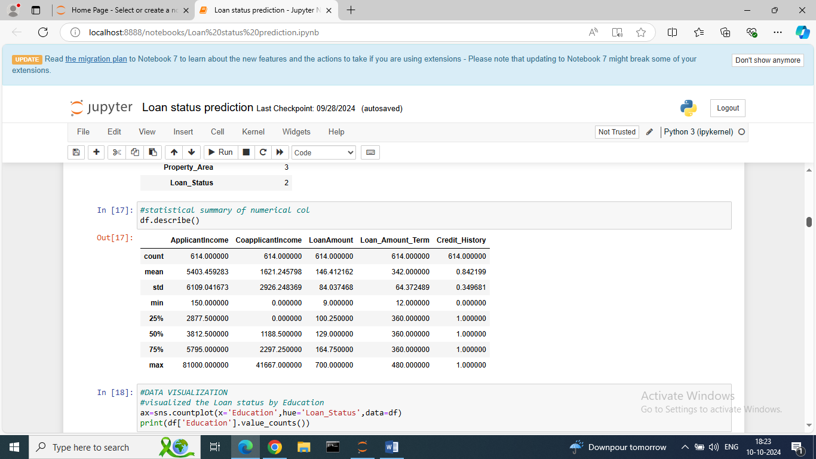

* We can see the statistical summary of only numerical columns not categorical columns.
* Count: The number of non-empty values of particular column.
* Mean: The mean value of particular column.
* Std: The standard deviation of particular column.
* Min: The minimum value of that particular column.
* 25%: The 25% percentile values of that particular column and this is the 1st Quartile
* 50%: The values between 25% and 50% of percentile of that particular column and this is lies between 1st and 2nd Quartile i.e. median
* 75%: The values between 50% and 75% of percentile of that particular column and this is lies between 2nd and 3rd Quartile.
* Max: The greatest value of that particular column.
* Data Visualization:

It means the graphical representation of data which is present in dataset.

Using seaborn, matplotlib libraries we are plotting various plots for visualization.

For this project we using countplot, catplot etc.

1. Visualising the loan status by Education.

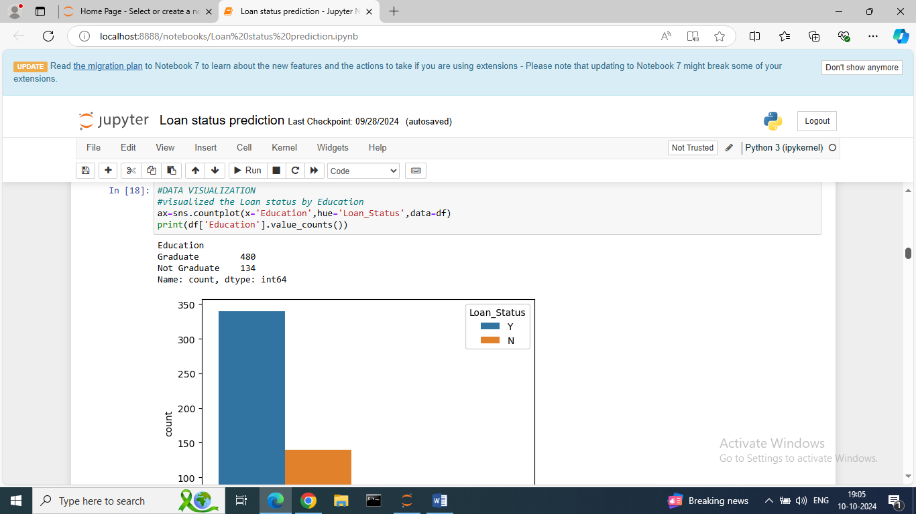

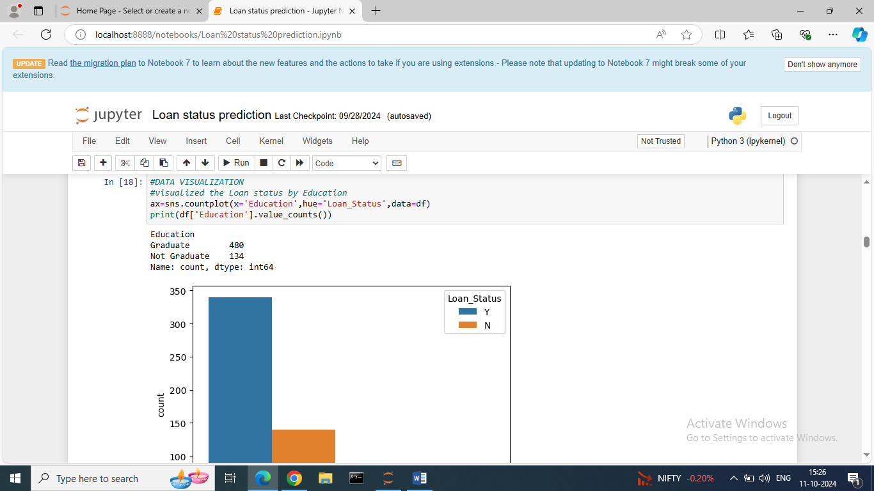

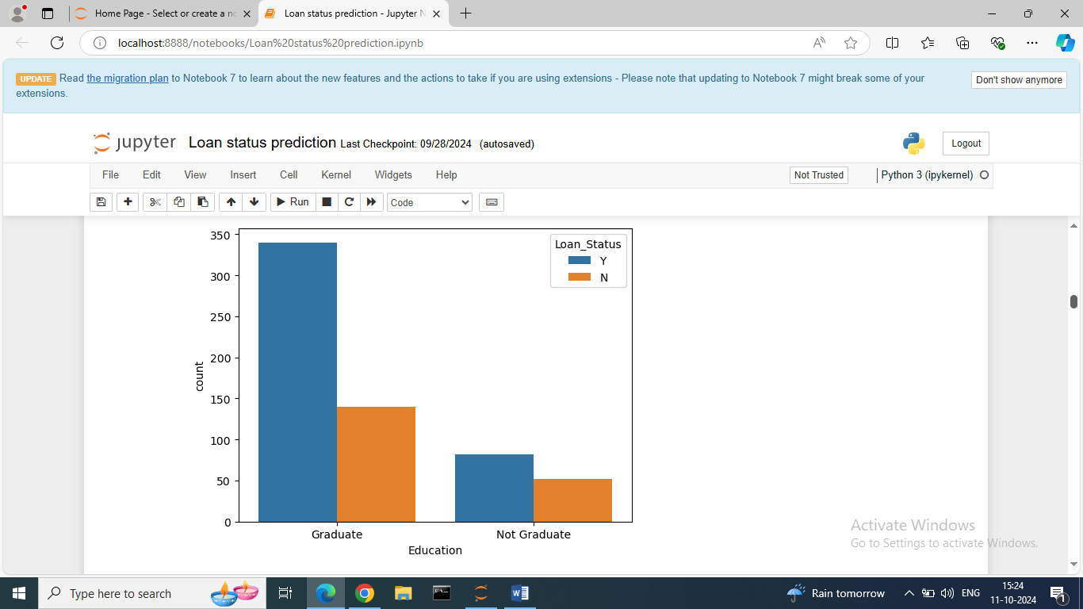

We can see in Education feature 2 Types of Educations – Graduate and Not- Graduate.

Here, we visualizing the loan status by Education.

We use the count plot for counting No. of educated applicants on the basis of loan status.

From above observation we can say the approval of loan of graduate applicants are more than the Non Graduate applicants.

1. Visualizing the Loan status by Marriage status.

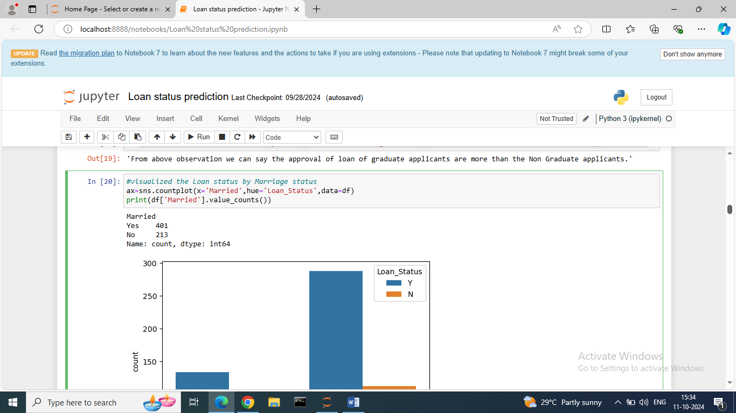

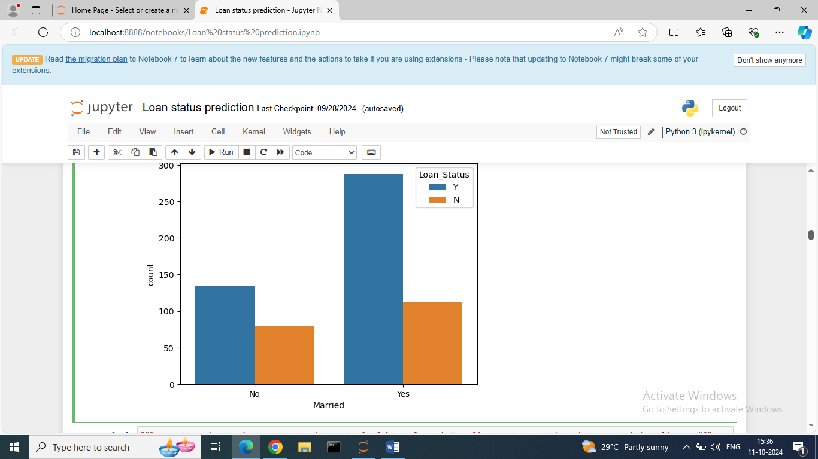

Here, we visualizing the loan status by Married Status.

We use the count plot for counting No. of Married applicants on the basis of loan status.

From above observation we can say the approval of loan of Married applicants are more than the Unmarried applicants.

1. visualizing the Loan status by Gender.

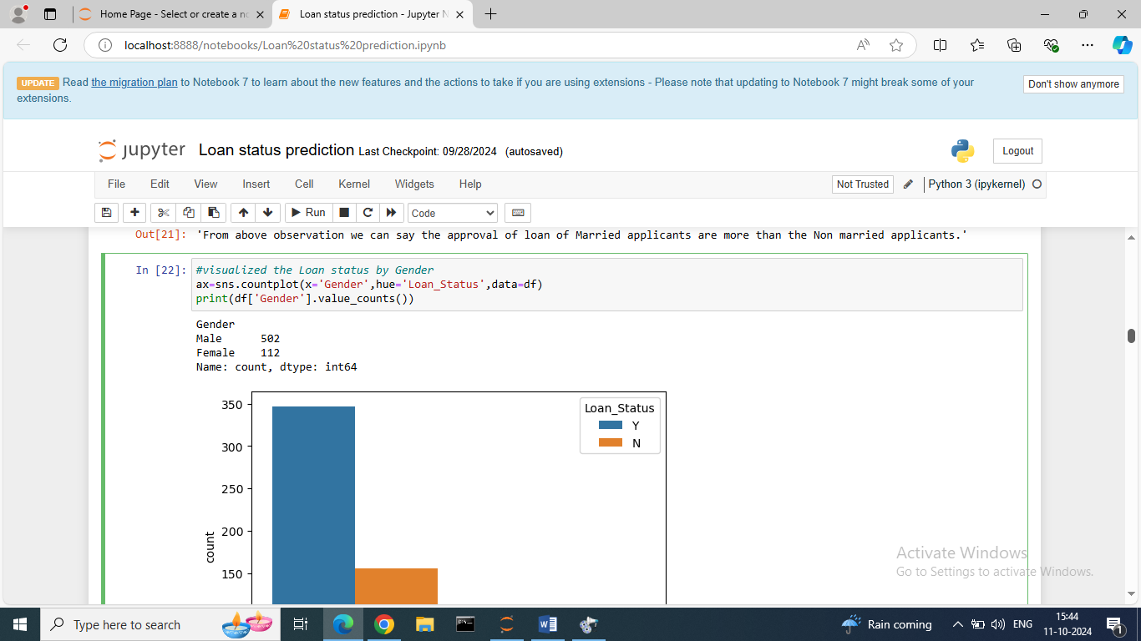

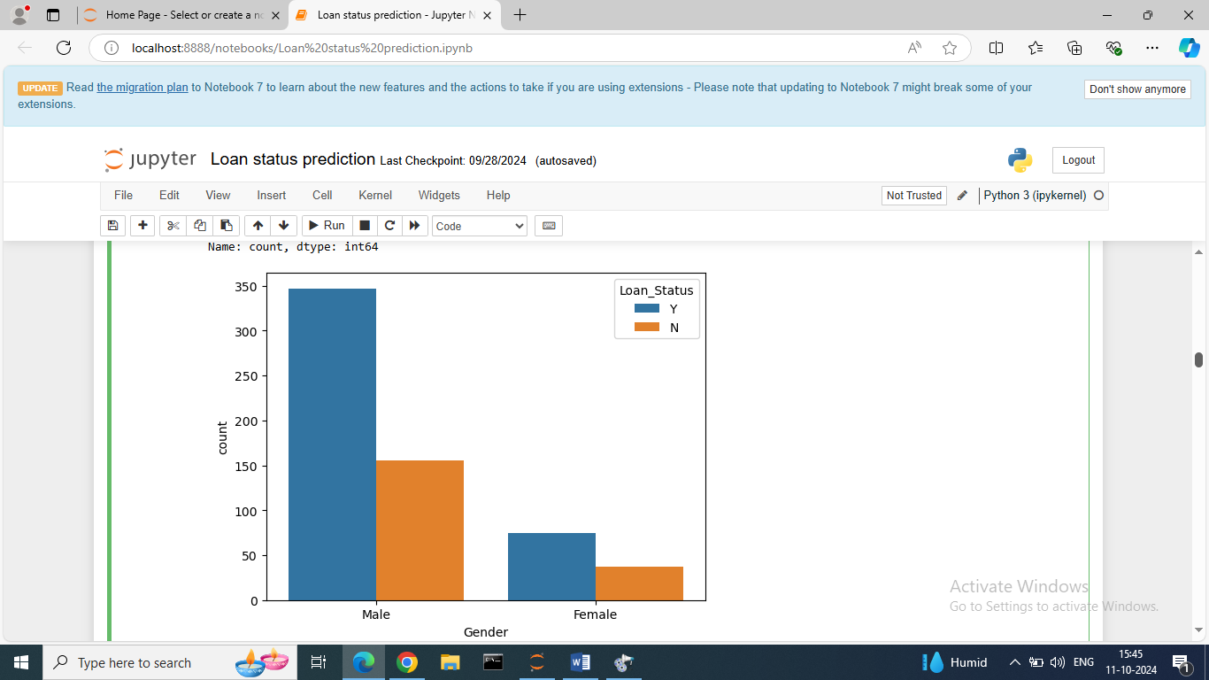

Here we can see the More Male applicants have been approved for loan than the Female applicants.

1. Visualizing the Loan status by Property area.

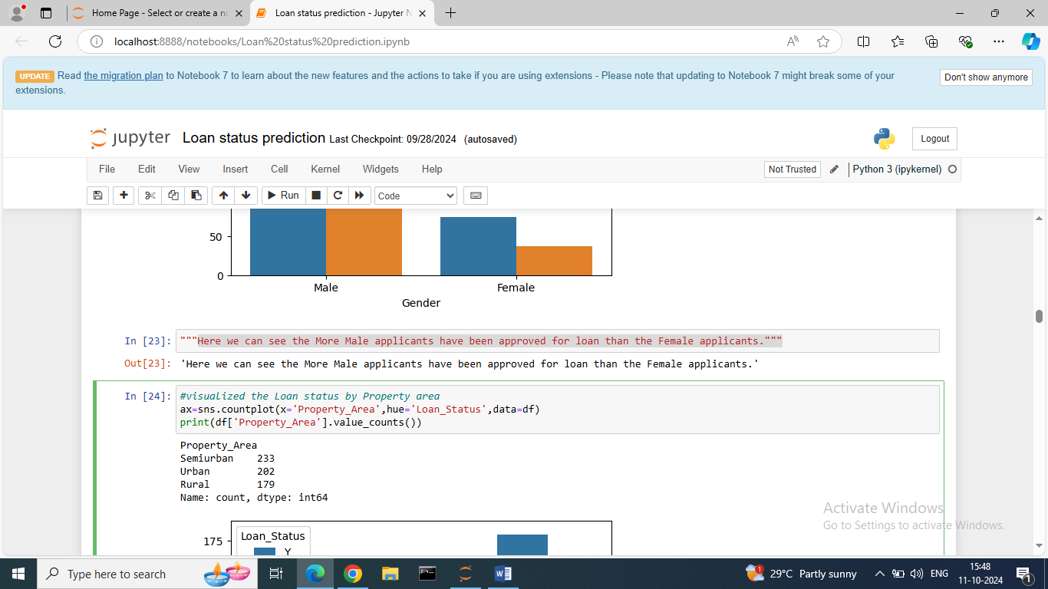

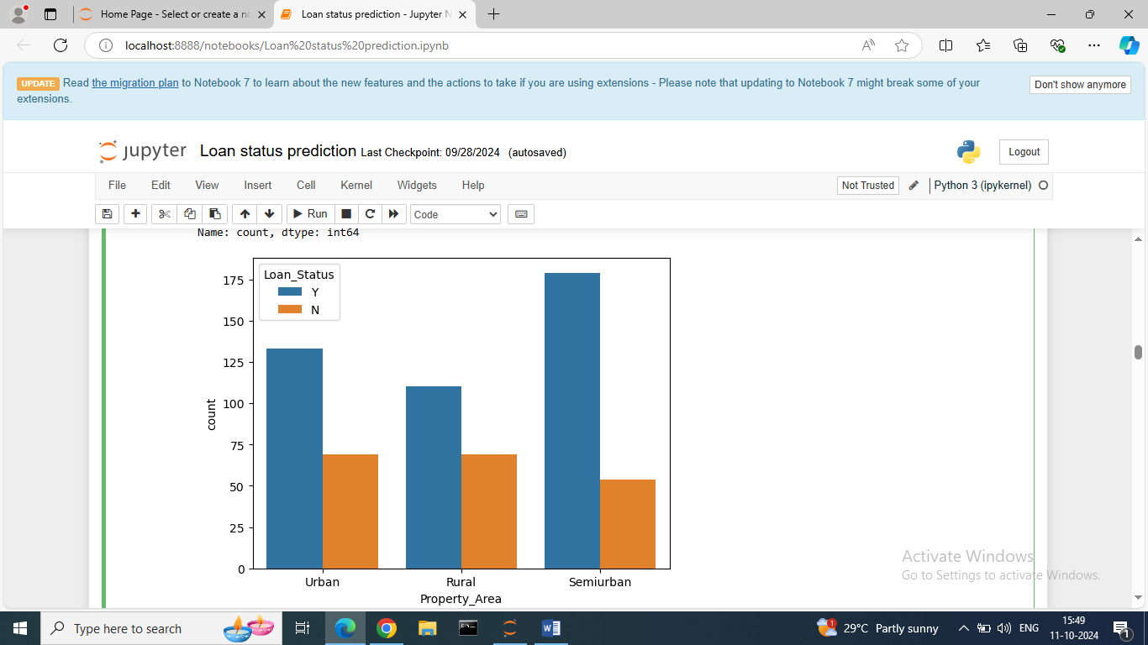

Here, we visualizing loan status by Property Area.

There are 3 Property area’s- Urban, Rural and Semi urban.

From above observation, in semi urban area's applicant are most approved for loan than other area's. Rural area's applicant is lesser approved for loan.

1. Checking Loan Status with Feature dependents.

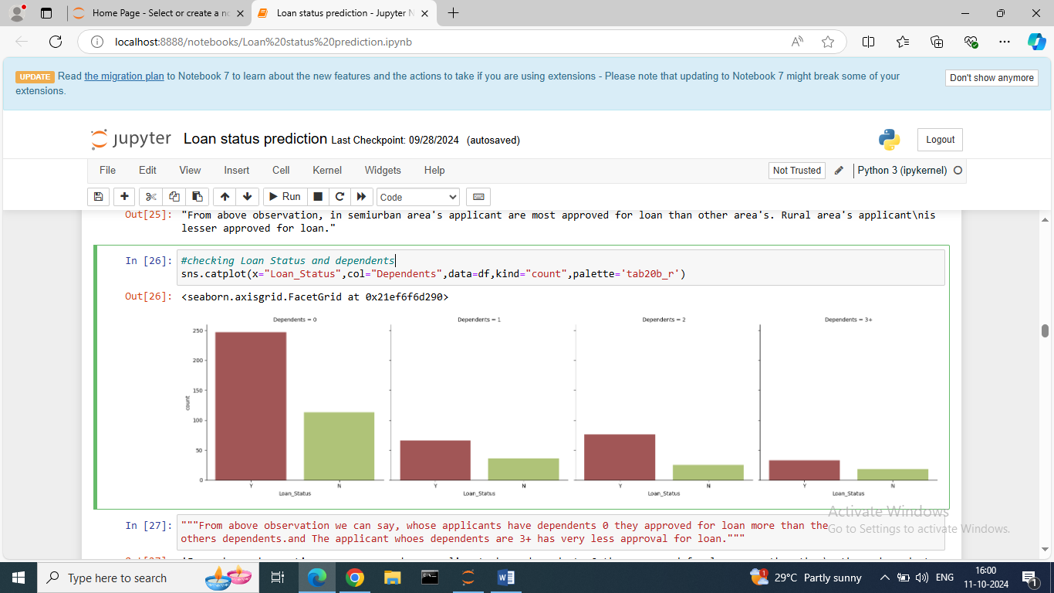

Here, we are checking the loan status by dependents using Cat plot.

In feature dependents – There are No. 0,1,2,3+ dependents are present.

From above observation we can see, whose applicants have dependents 0 they approved for loan more than the others dependents, and The applicant whose dependents are 3+ has very less approval for loan.

* For better understanding we are separating Numerical and Categorical columns.

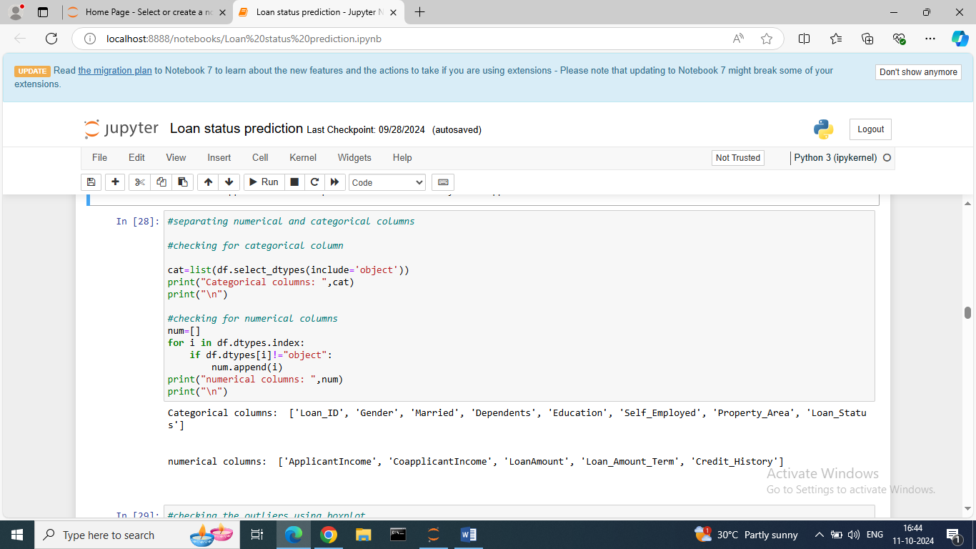

Categorical columns :Loan id, Gender, Married, Dependents, Education, self employed, Property area, loan status.

Numerical Columns : Applicant Income, Co applicant Income, Loan Amount, Loan Amount term, credit history.

As per problem statement need to do predict the loan status.

Therefore, Loan Status is our target variable.

Loan status is in categorical nature, so for model building we use classifier Algorithm.

For model building first need to do Pre-Processing Pipeline.

Pre-Processing Pipeline:

We completing data analysis, EDA.

Now, we are checking is any outliers, skewness of data, correlation between features and target, feature scaling, checking variance inflation factor(VIF), checking data is balanced or imbalanced etc.

* Outliers:

For the model building need to check is any outliers are present or not.

Outlier means, a data point that is significantly different from other values in a dataset.

Here, we are detecting the outliers using boxplot.

-Boxplot is a visual method to detect the outliers in dataset.

-That plots the 25% percentile(q1), 50%percentile or median (q2), 75%percentile (q3) of the data.

- Outliers are plotted as points above and below the plot.

From only numerical data can detect and handle the outliers.

Cannot detect outliers from categorical data.

Code for detecting outliers.

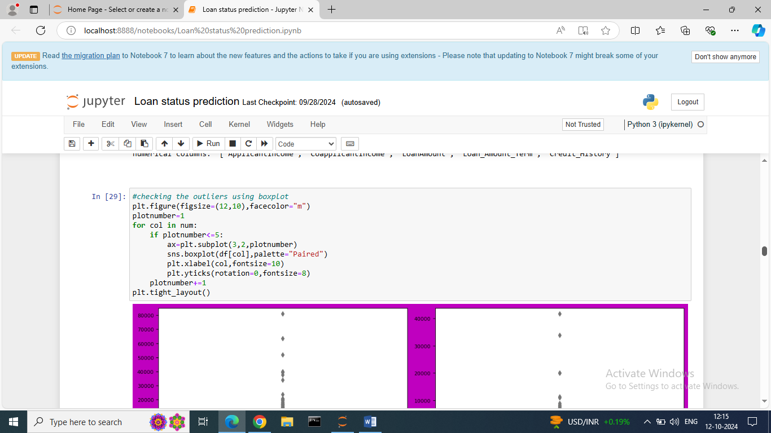

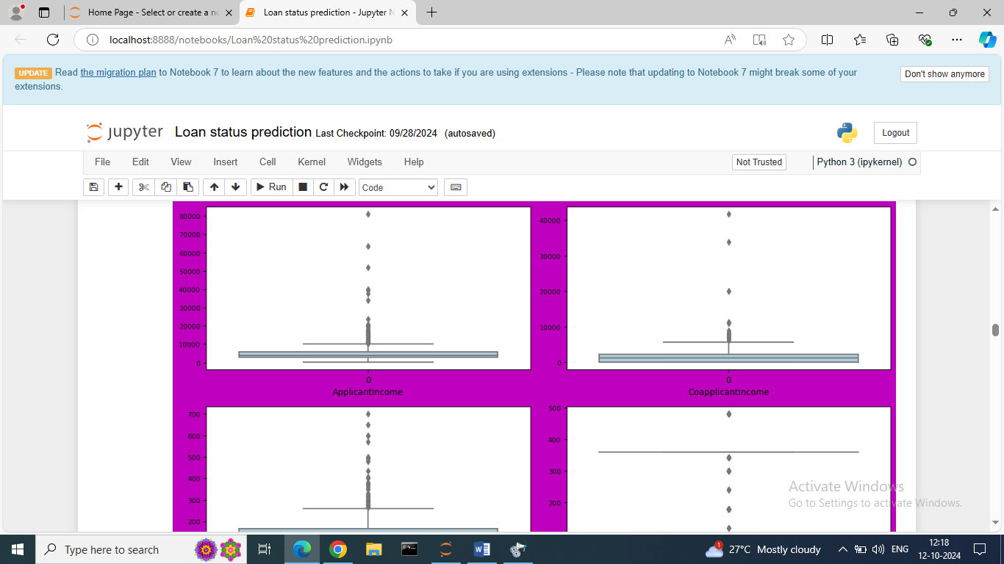

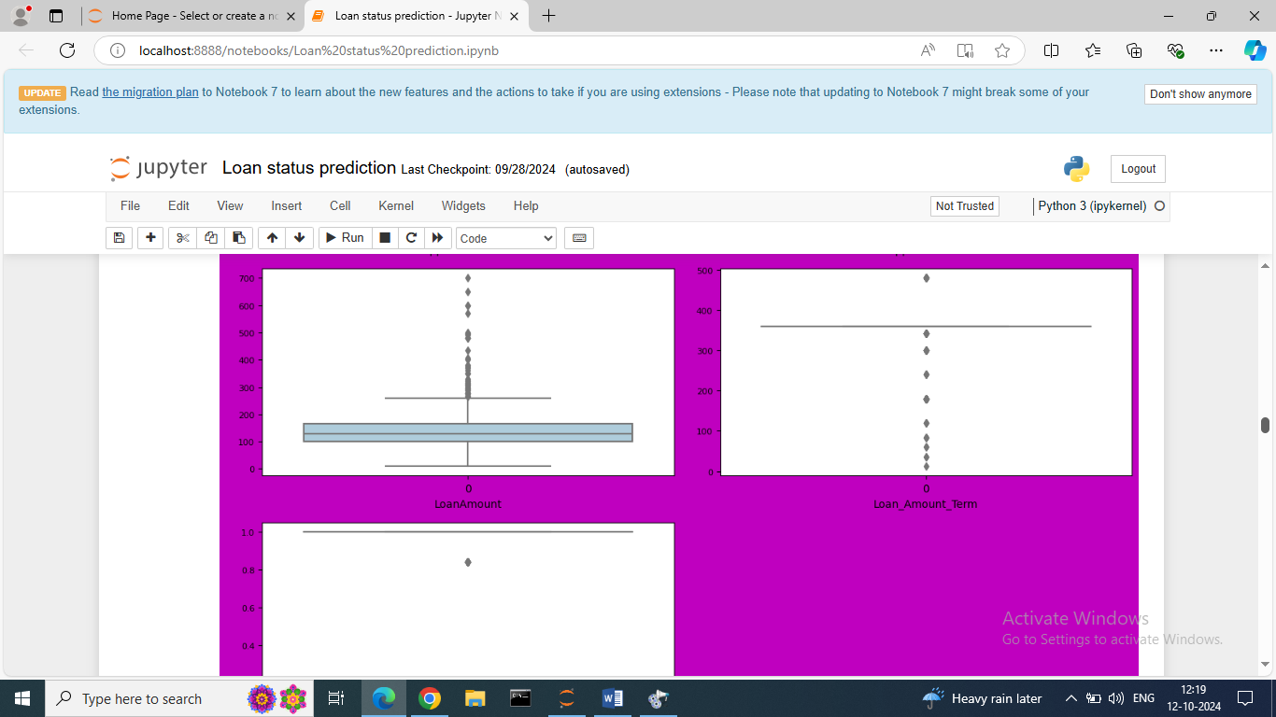

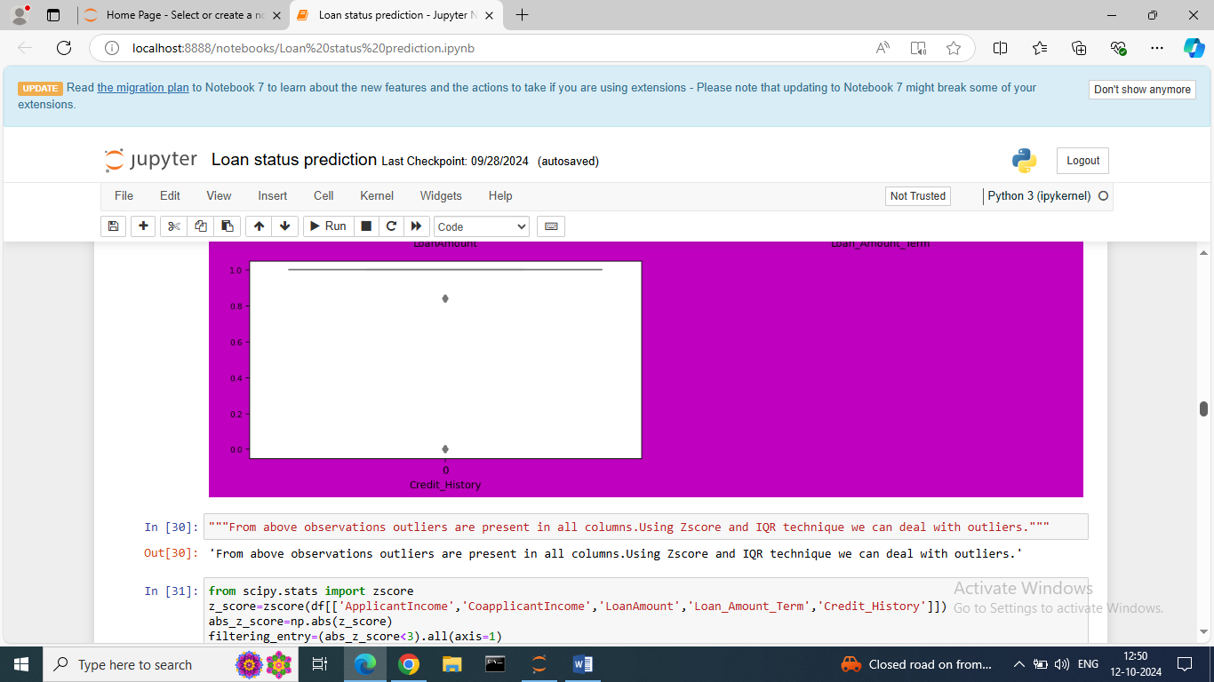

From above observations outliers are present in all features. Using Z score and IQR technique we can deal with outliers.

1. Z score: z score Is also known as standard score.

Z score tells how many standard deviations away a data point is from the mean.

Formula:

Z score =(x-mean)/std. deviation

X = value being evaluated

Following are the application of z score

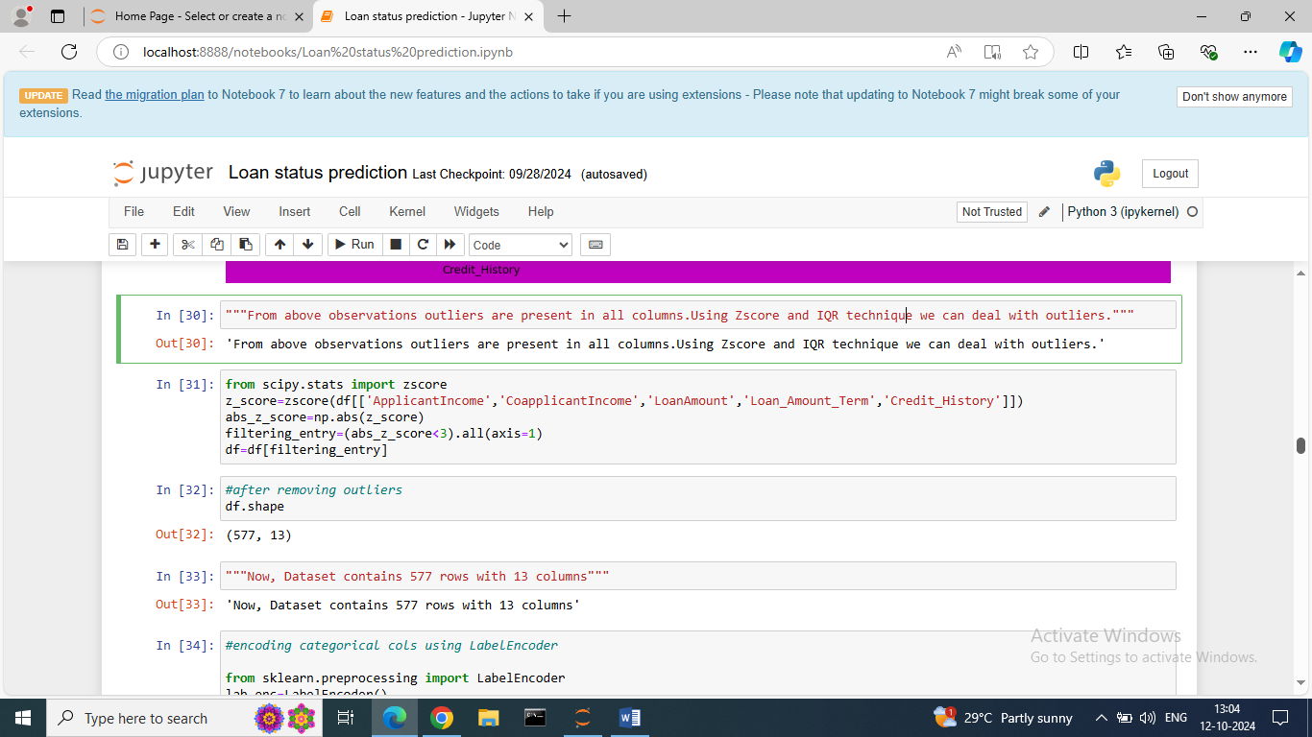

Here, importing the zscore from scipy.stats library.

We taking directly threshold as 3.

Whichever the absolute z score values < 3 means it shows the outliers . It will be remove as filtering entry.

After the removing outliers the shape of dataset is changed.

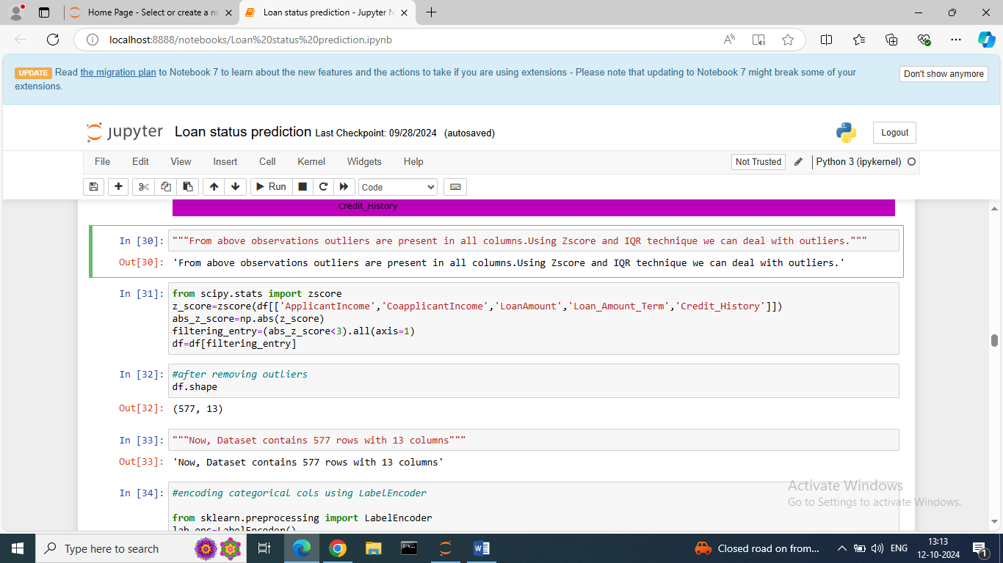

Before processing the shape of dataset is (614,13): 614 – rows, 13 – columns

After processing the shape of dataset is (577,13): 577 – rows, 13 – columns

* Encoding:

Now encoding categorical columns using Label Encoder.

There are so many encoding methods like One hot encoding, Label encoding, Ordinal encoding etc.

Here we take Label encoder.

Its convert the categorical data into 0 and 1 integer.

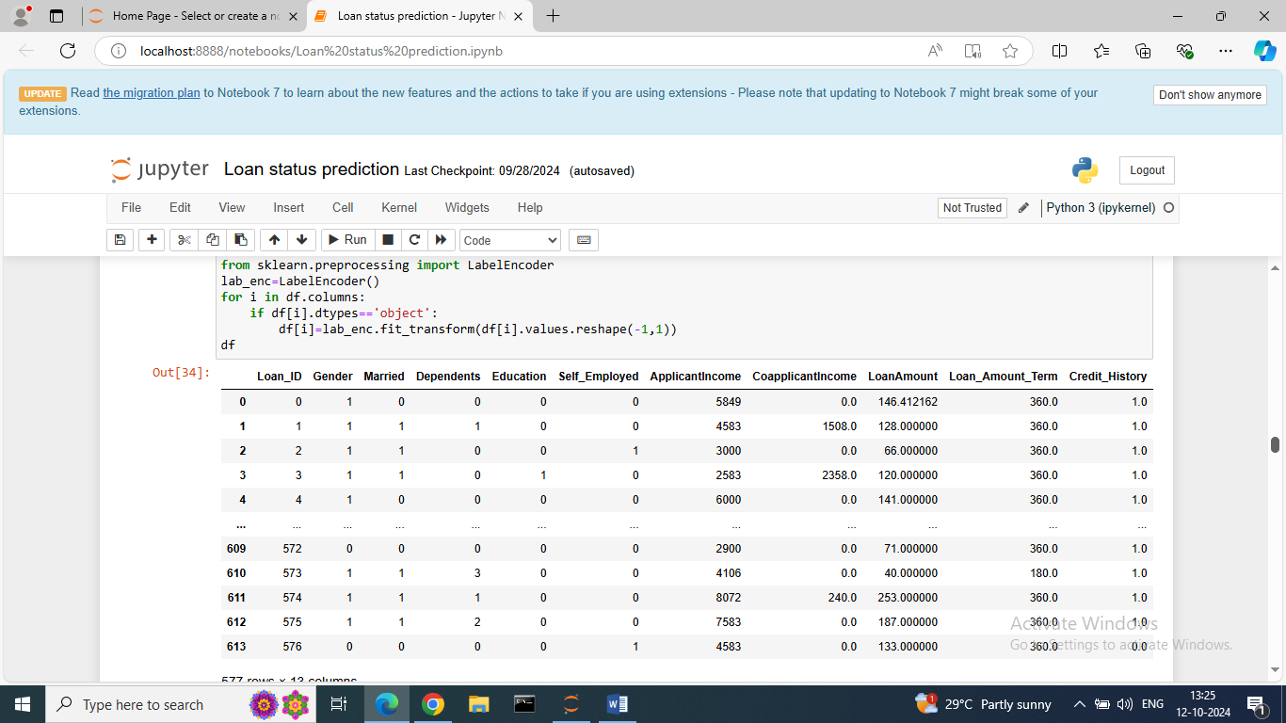

* Skewness: It shows the distribution of data.

There are 3 types of skewness.

1. Positive skewness: In a positively skewed distribution, the tail of the distribution extends towards the right side.

It is also known as right Skewness because longer tail is on the right side when graphed.

1. Negative Skewness: In a Negatively skewed distribution, the tail of the distribution extends towards the left side.

It is also known as left Skewness because longer tail is on the left side when graphed.

1. Zero Skewness: In zero skewness the data is in bell curve normal distribution.

Using distplot we can see how the data is distributed for every feature.

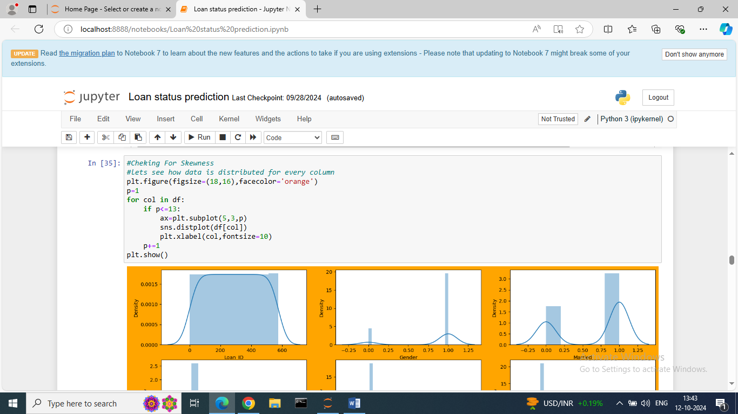

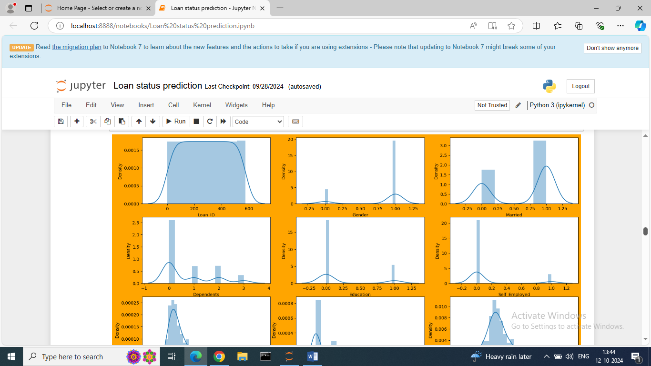

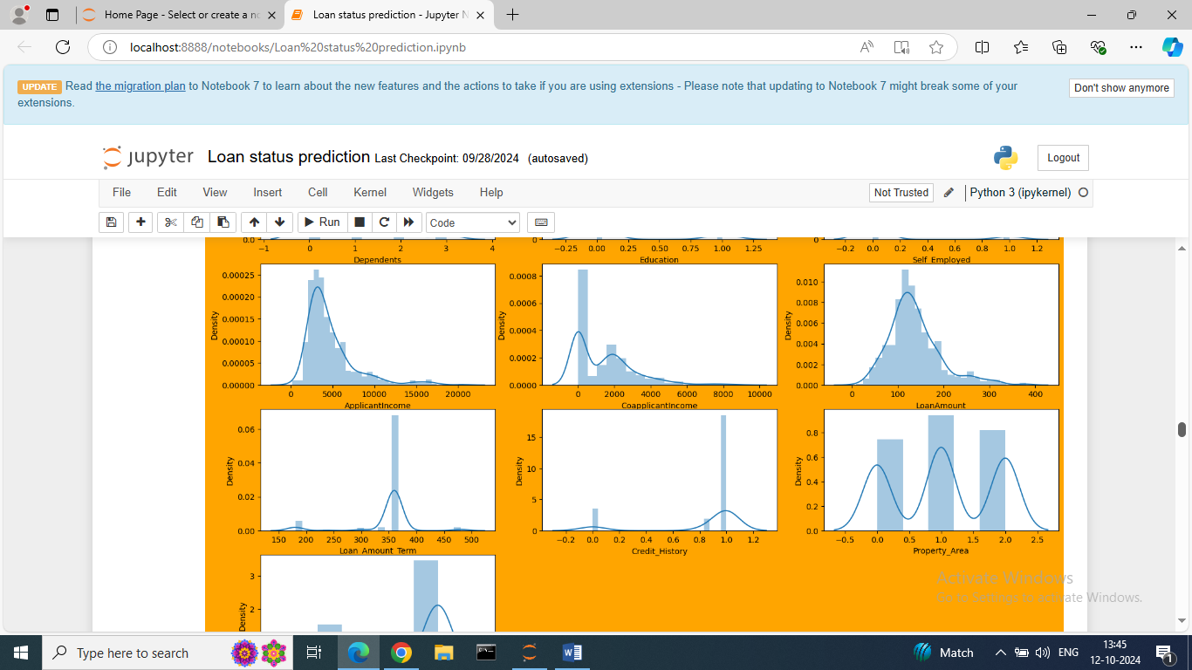

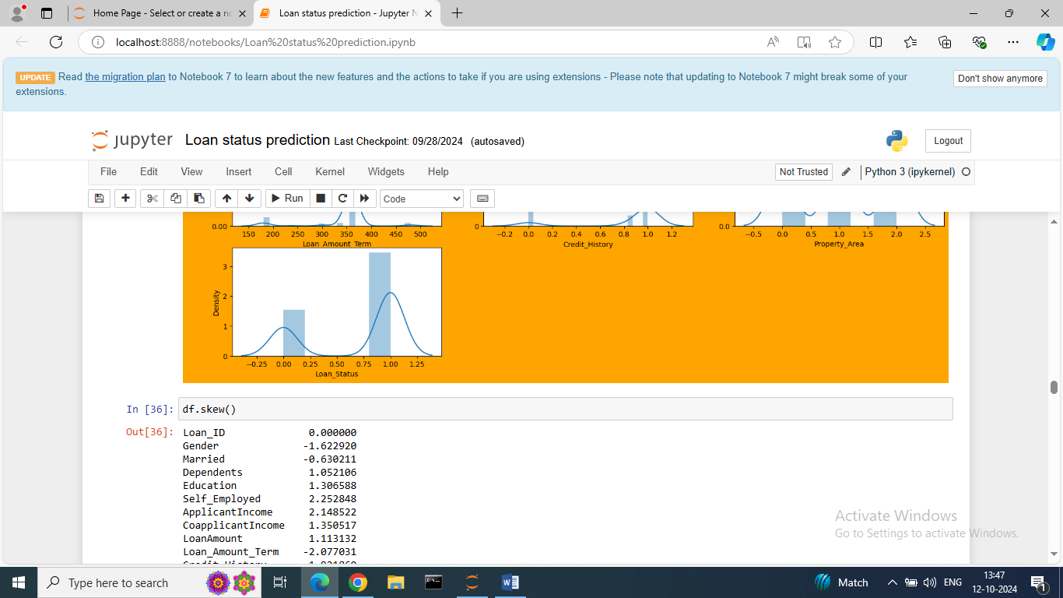

From above observation the positive skewness is present in Dependents, self employed, Applicant income, co applicant income, loan amount.

The negative skewness in gender, loan amount term, credit history.

Zero skewness in loan id, loan status.

The skew () method is also use for calculating the skew for each column.

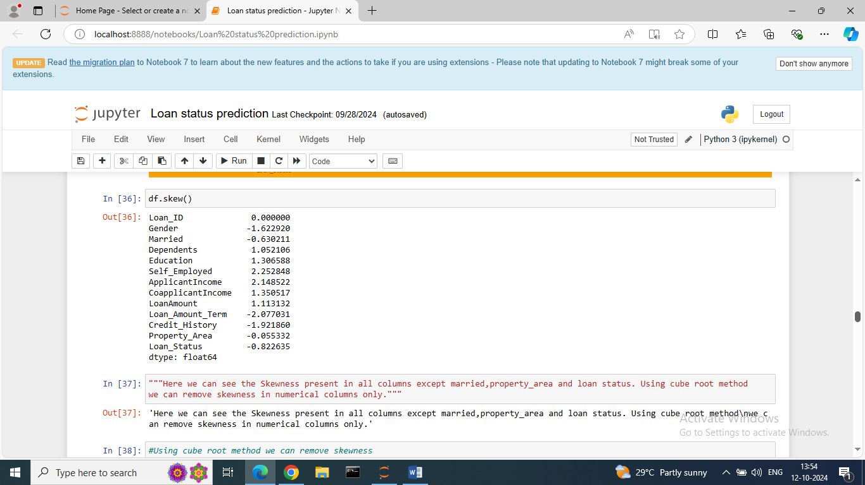

We can handle the skewness in only numerical data not from categorical data.

There are so many methods for handling skewness like squared, cube root, Box-cox etc.

Here we are handling skewness using Cube root method.

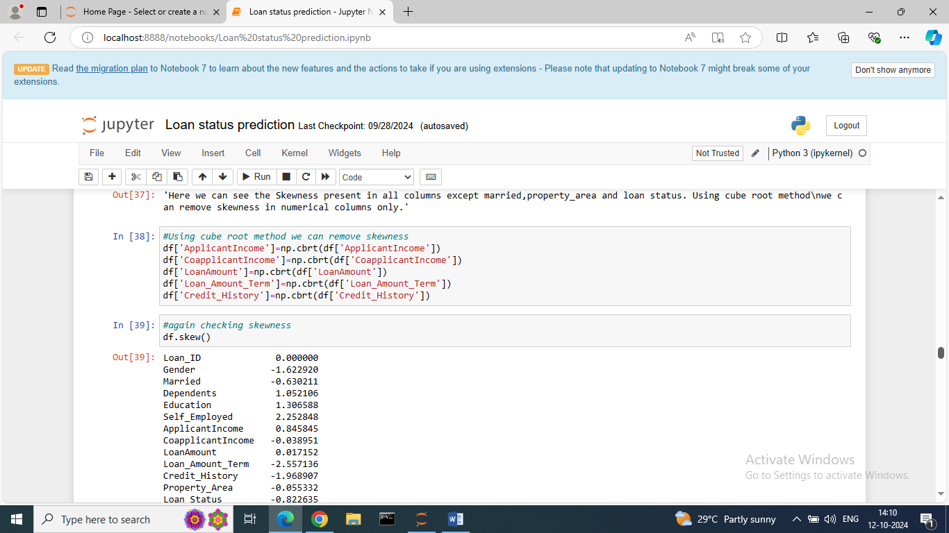

* Dropping unnecessary columns.

For model building the feature loan id is not having any important information so we drop it using drop method.

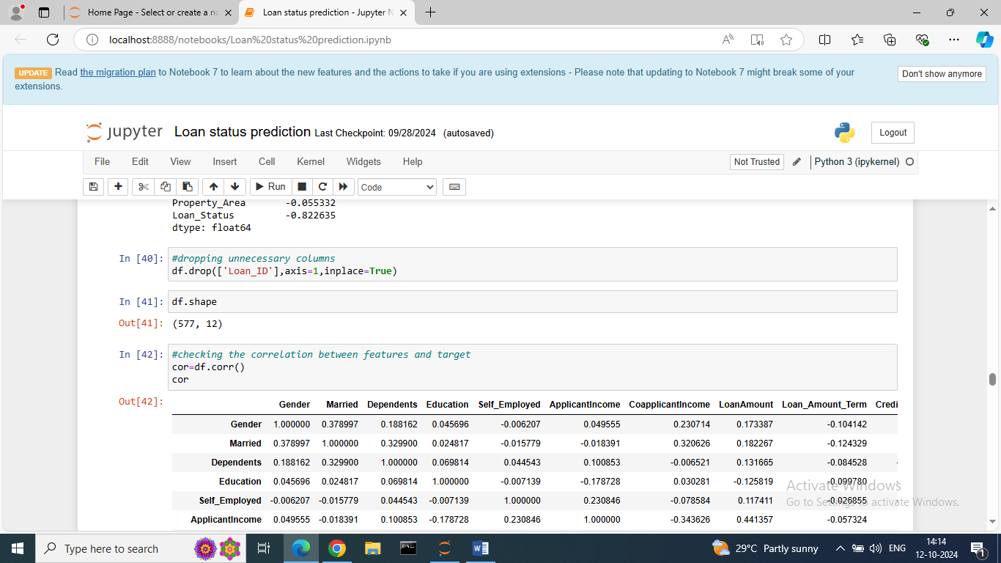

After dropping loan id column now dataset contains 577 rows with 12 columns.

* Correlation: This method is used for checking the relation between features and target.

Corr () shows the one feature is related to other features.

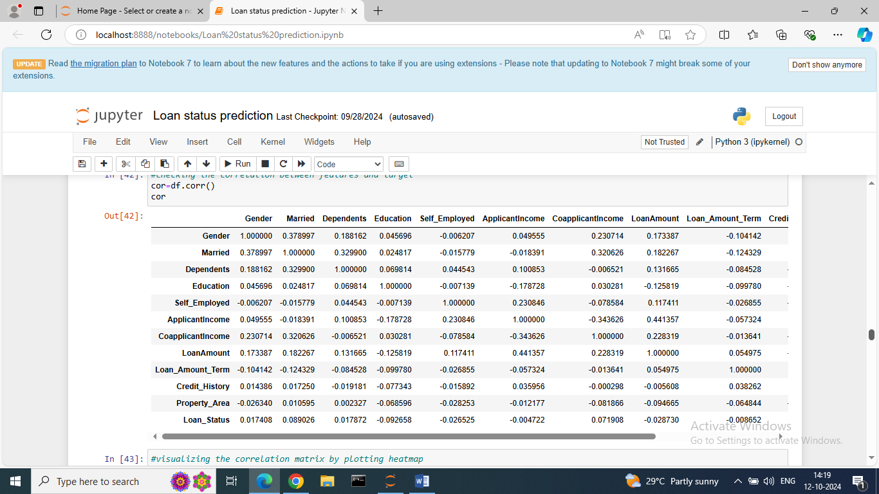

Visualizing the correlation matrix by plotting heat map.

Heat map represents the data using colors to visualize the value of each data point in matrix.

In correlation heat map, each cell’s color represents the strength of the correlation between two variables. Brighter colors indicate a stronger positive correlation, while darker colors indicate a stronger negative correlation.

The diagonal line in a correlation heat map is usually solid or has the highest value, representing the correlation of each variable with itself which is always equal to 1.

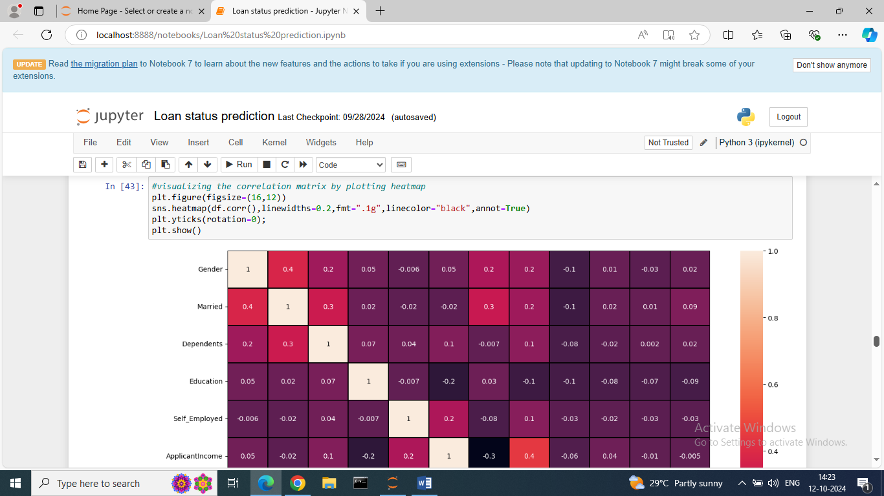

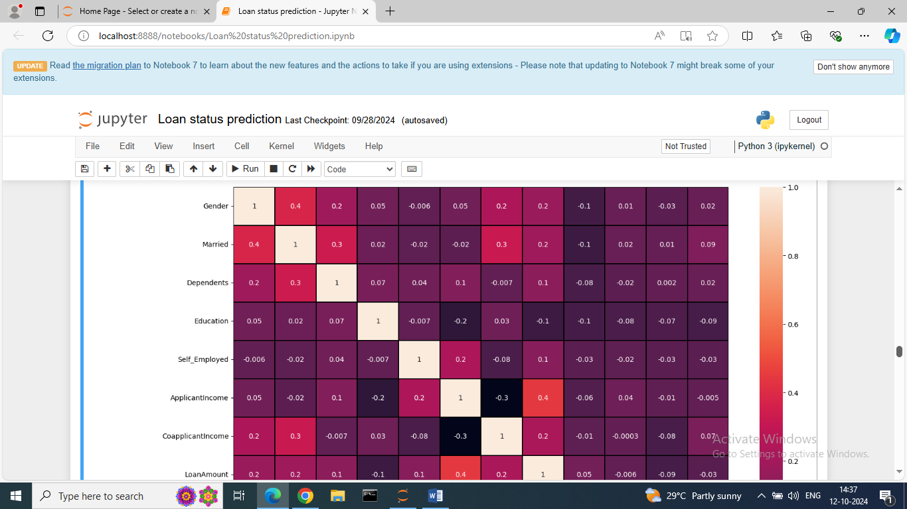

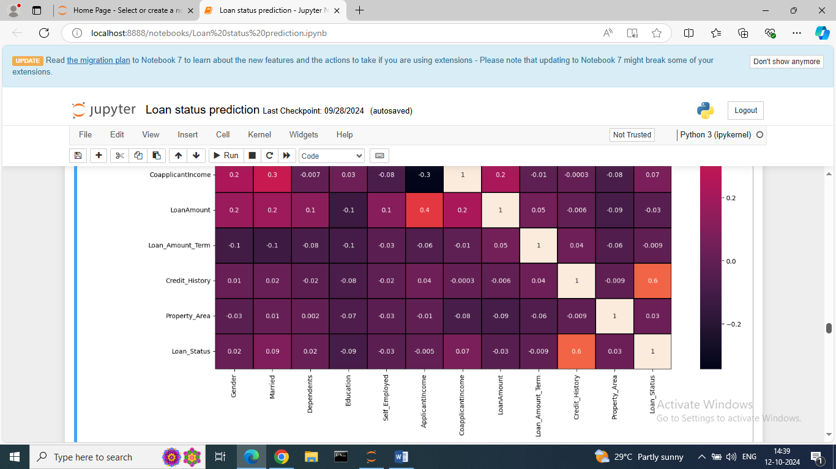

The range of positive correlation is 0 to 1.

The range of negative correlation is 0 to -1.

From above observation married, co applicant income are positively correlated to target i.e. loan status and credit history is strong positively related.

Observation of the positive and negative correlated features with target variable.

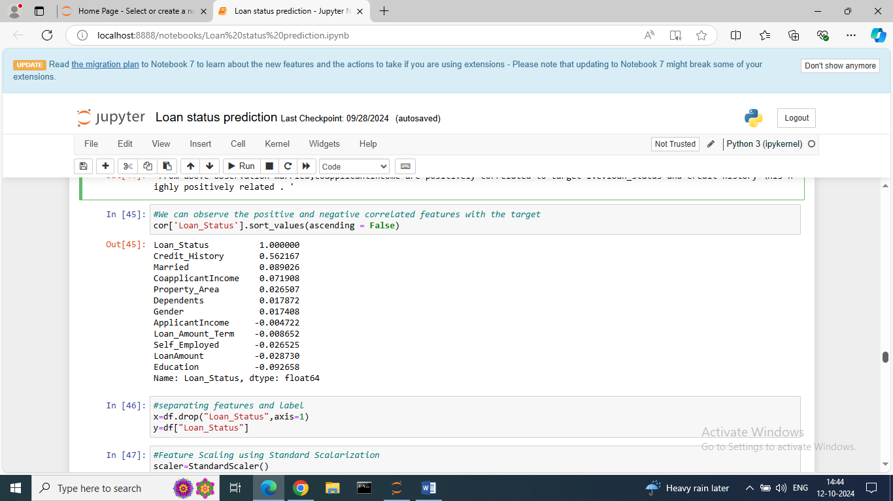

* Separating the features and label for prediction.

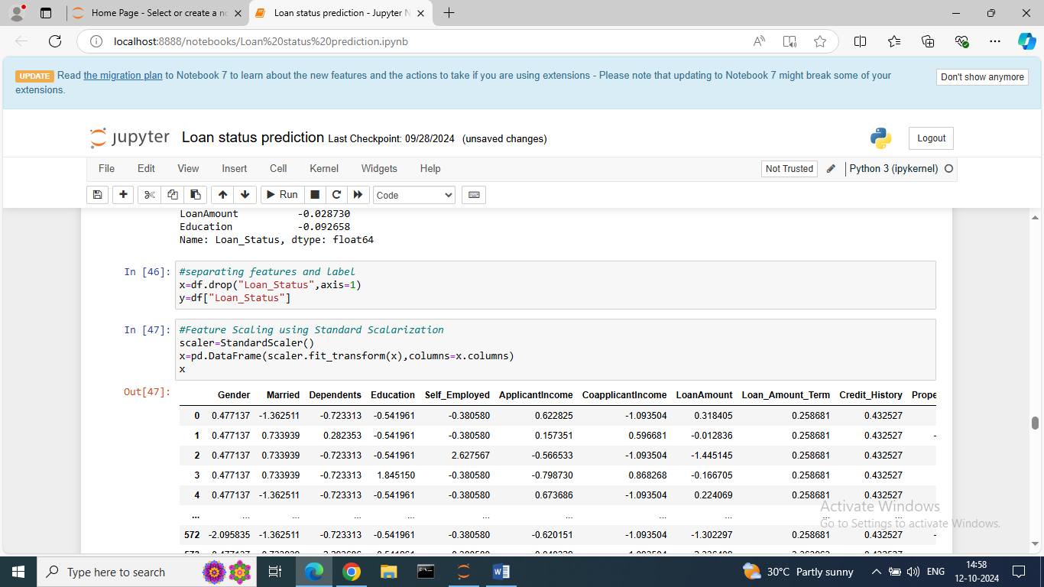

Here, separating label for prediction and it is store in y variable.

* Feature Scaling: The feature scaling using Standard scalarization.

Feature scaling is a technique to standardize the independent features present in the data in a fixed range.

It improves the algorithm performance.

This method of scaling is based on the central tendencies and variance of the data.

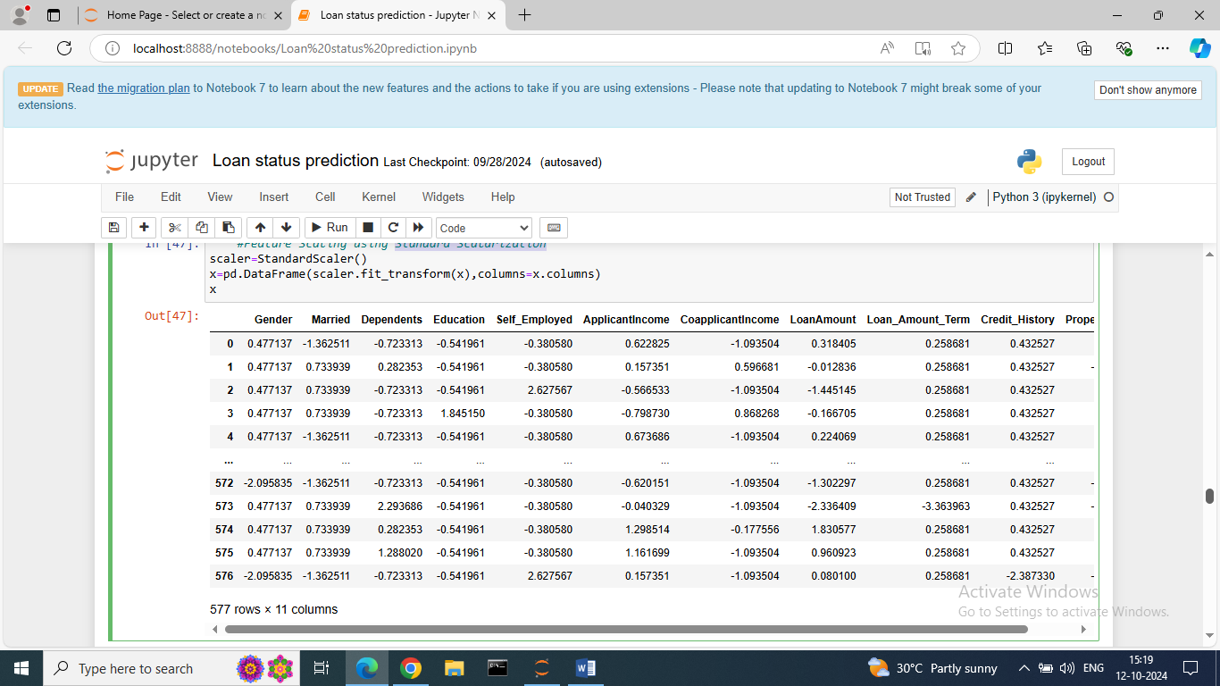

* Variance Inflation Factor (VIF):

VIF values are used for checking any multi collinearity issues.

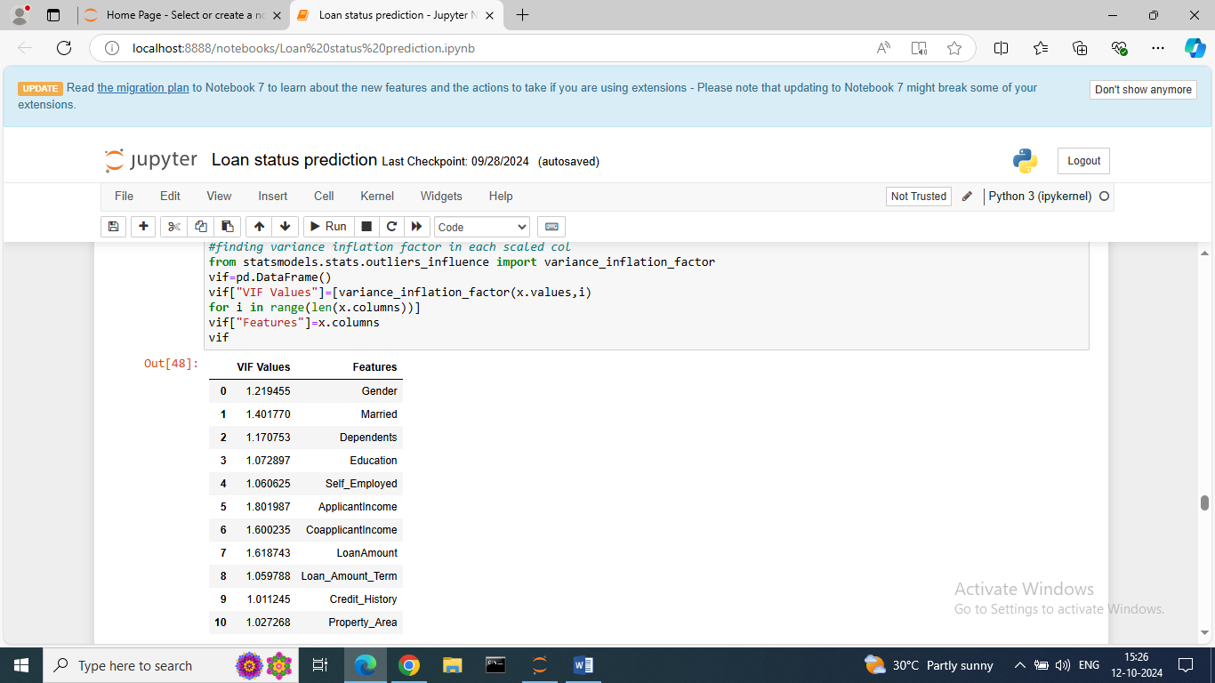

It shows the VIF values of all independent variables.

If the VIF Values > 10 then we can say there is multi collinearity issue.

So, here VIF values < 10, there is no multi collinearity issue.

* Oversampling using SMOTE:

Here, 1st checking the value counts of target variable.

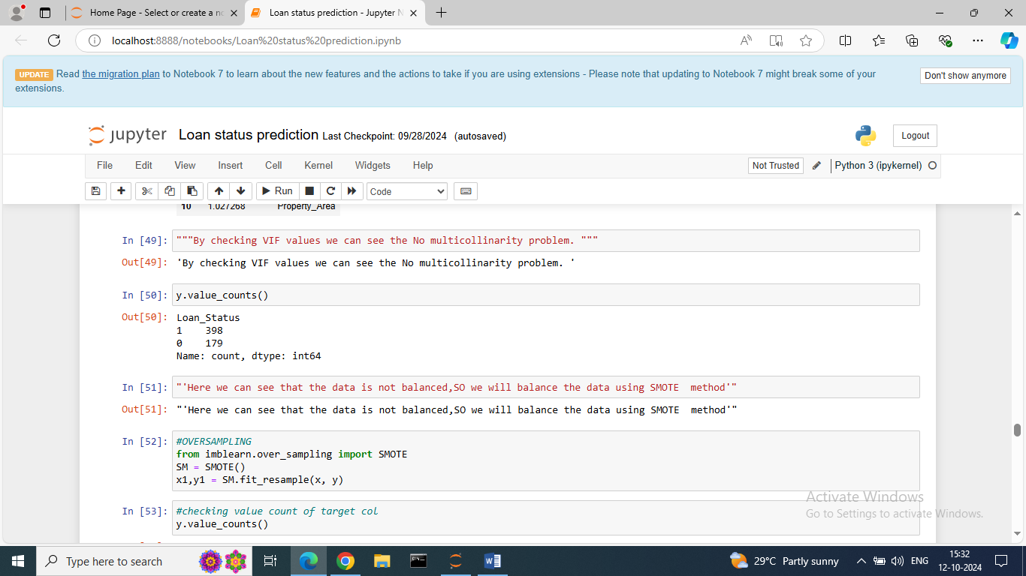

The data is not balanced, so we will balanced the data using SMOTE method.

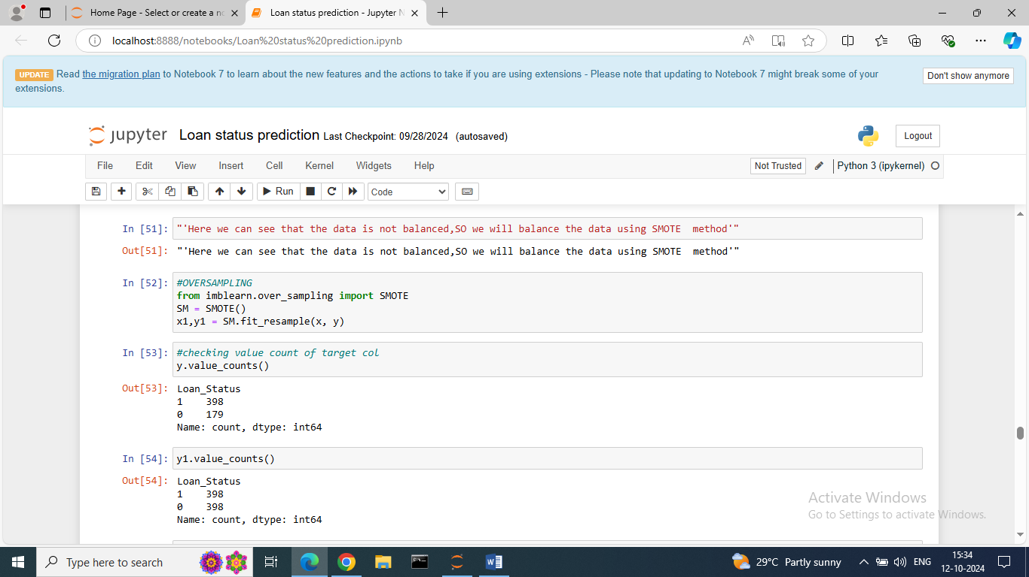

After SMOTE method the data is balanced and it is store in y1 variable.

We also visualized count plot for target variable.

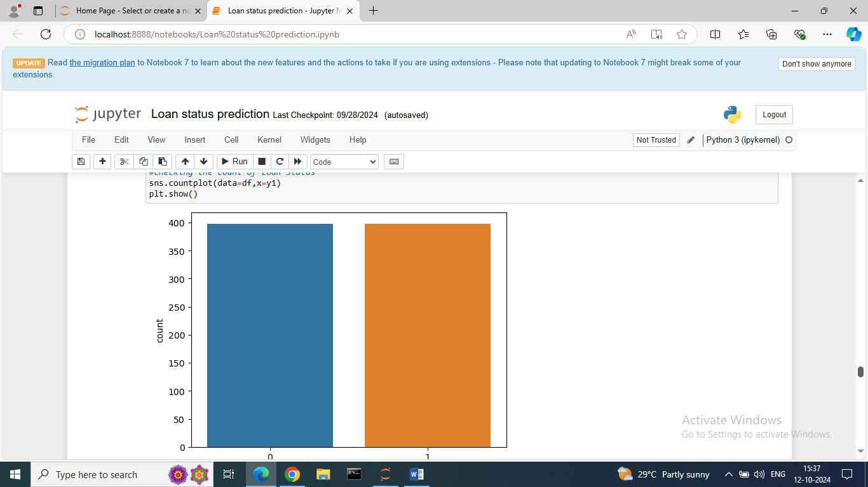

Building Machine Learning Models:

* For building model 1st splitting data into test and train.

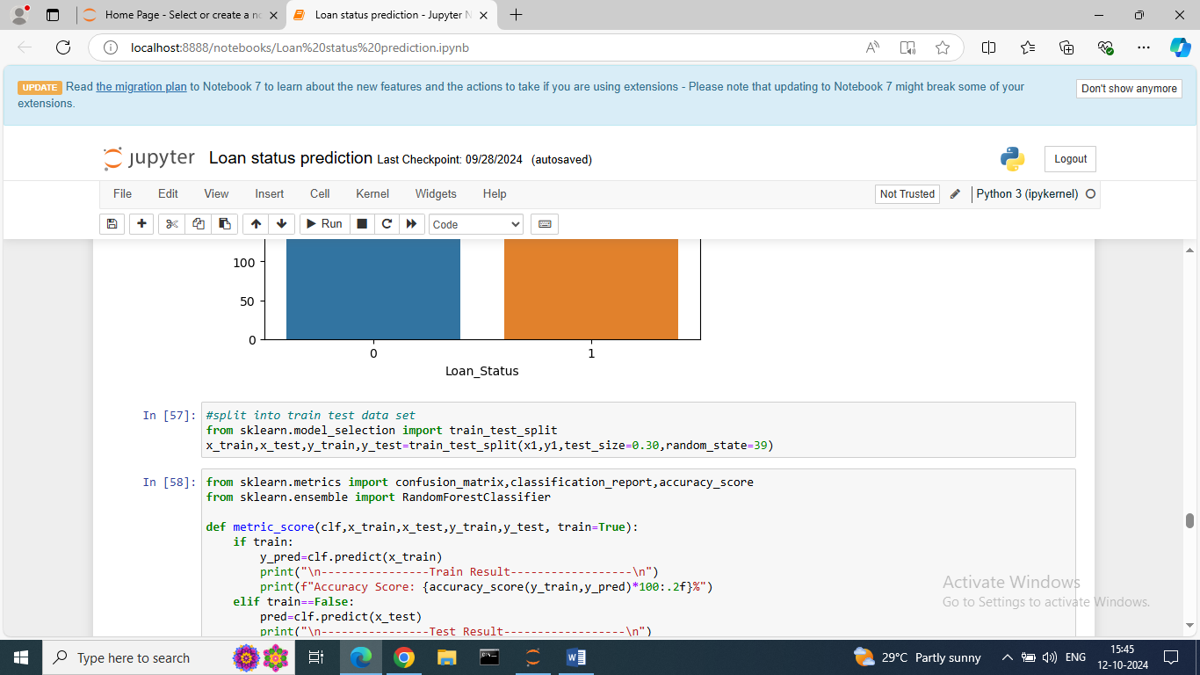

Here, we give 30% of data for testing at random state 39.

As per problem definition we need to predict loan status of applicant which is classification problem.

Therefore, here we tried prediction using Random Forest Classifier, Logistic Regression, Extra Trees Classifier, Gradient Boosting Classifier.

The evaluation metrics for classification problem is following:

1. Accuracy: The total number of correct classifications by the total number of classification.
2. Recall: It is a measure of from the total number of positive results how many positives were correctly predicted by the model.
3. Precision: Proportion of true positive prediction among all positive predictions.
4. F1 score: F1 score is defined as the harmonic mean of precision and recall.
5. AUC ROC: Measure of the models ability to distinguish between classes.
6. Confusion Metrics: It showing the count of true positives, true negatives, false positives, false negatives values.

* Random Forest Classifier:

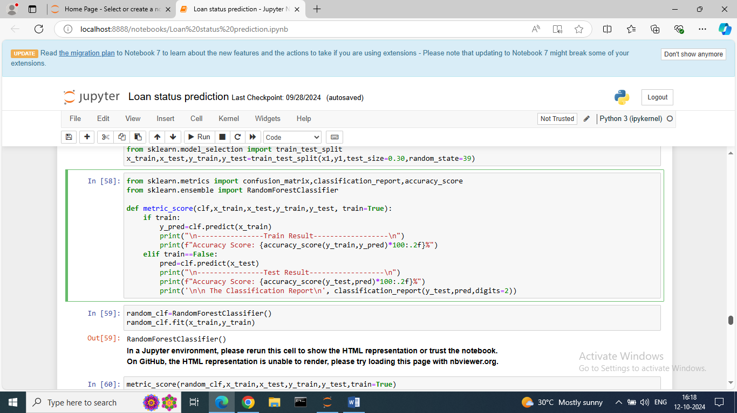

We creating one function metric_score for finding the accuracy of train and test data for all algorithm.

Only need to change classifier name and call the function for getting accuracy of all algorithms.

Now, fit the training data on random forest classifier and calling the metric score function.

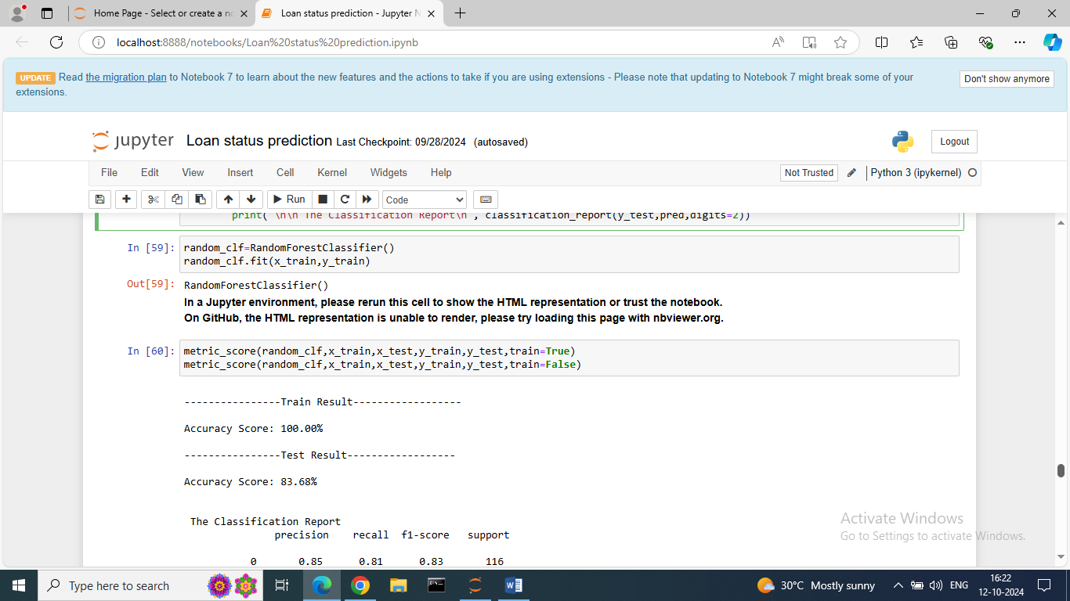

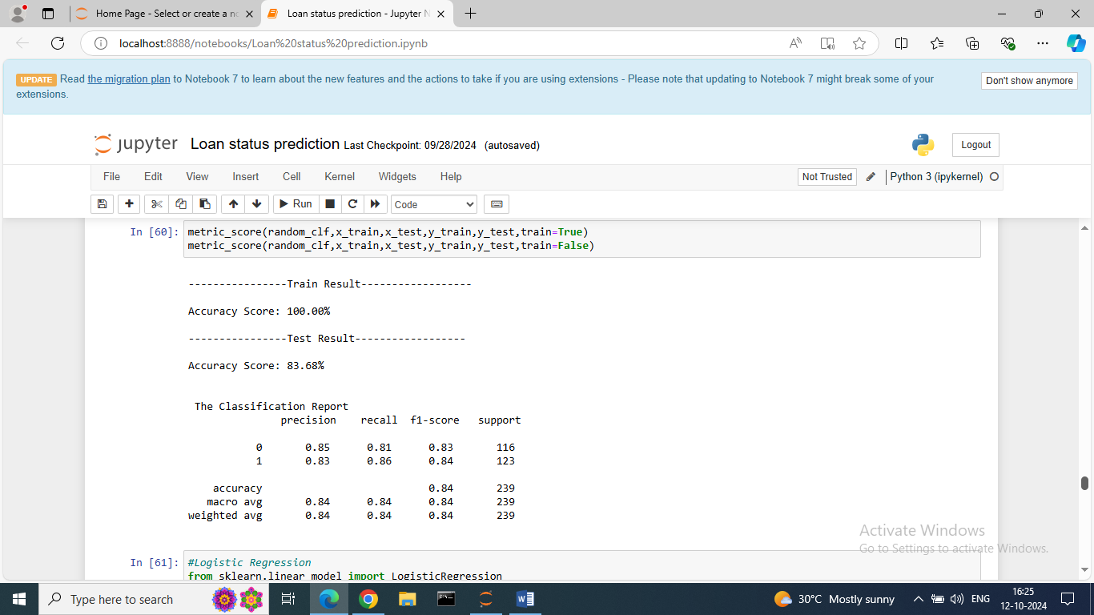

The accuracy of Train data: 100%

The accuracy of Test data: 83.68%

Same process for other 3 algorithms.

* Logistic Regression:

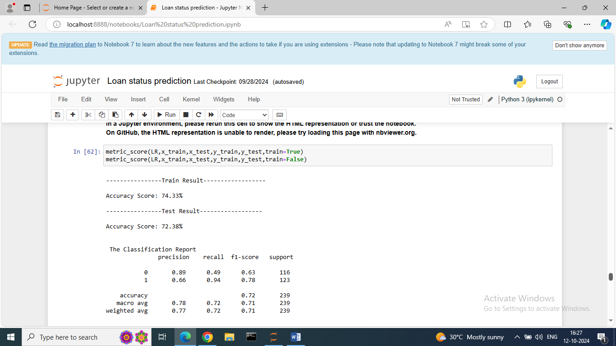

The accuracy of Train data: 74.33%

The accuracy of Test data: 72.38%

* Extra Trees Classifier:

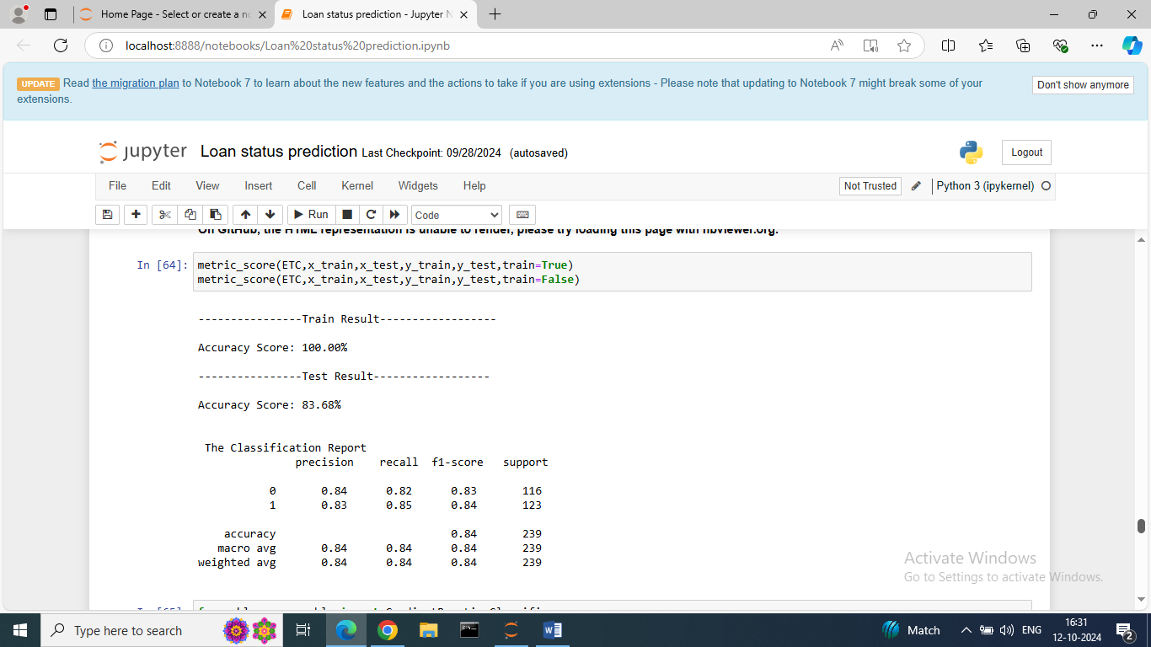

The accuracy of Train data: 100%

The accuracy of Test data: 83.68%

* Gradient Boosting Classifier:

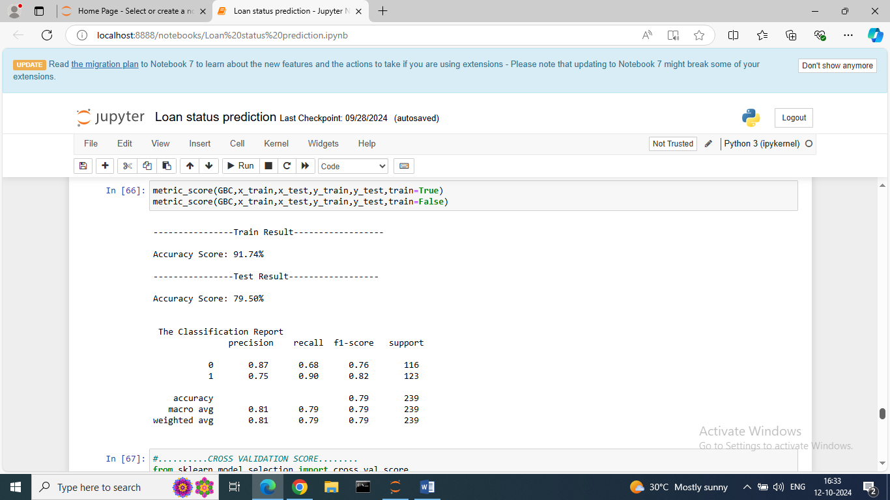

The accuracy of Train data: 91.74%

The accuracy of Test data: 79.50%

* Cross Validation Score: Cross validation is a technique used to evaluate the performance of a model on unseen data.

The main purpose of cross validation is to prevent overfitting.

1. CV score for Random Forest Classifier:

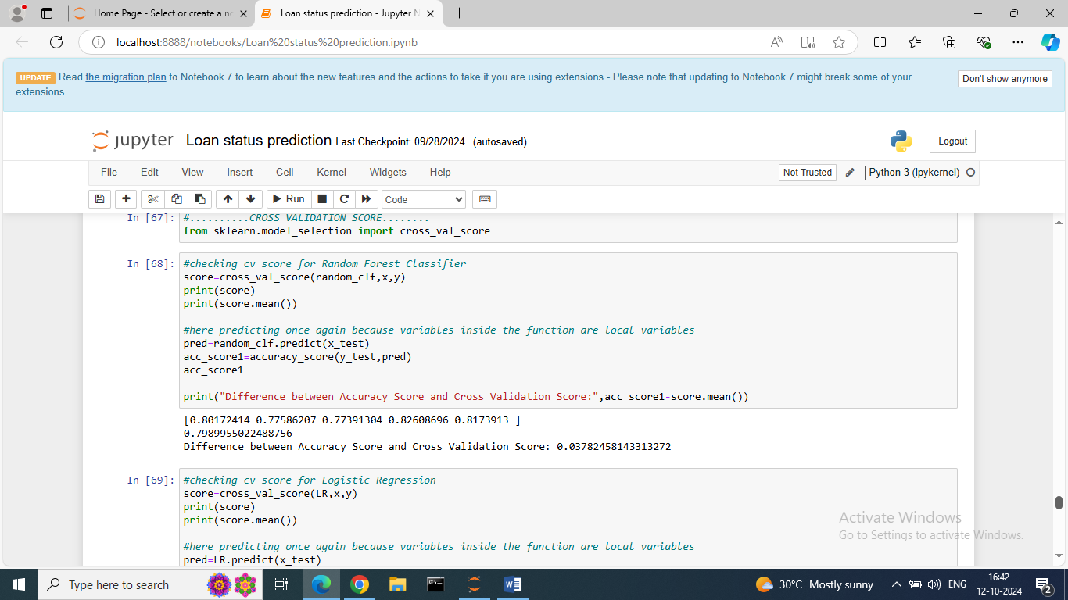

1. CV score for Logistic Regression:

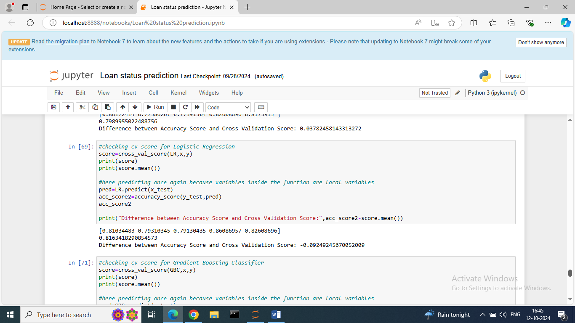

1. CV score for Extra Trees Classifier:

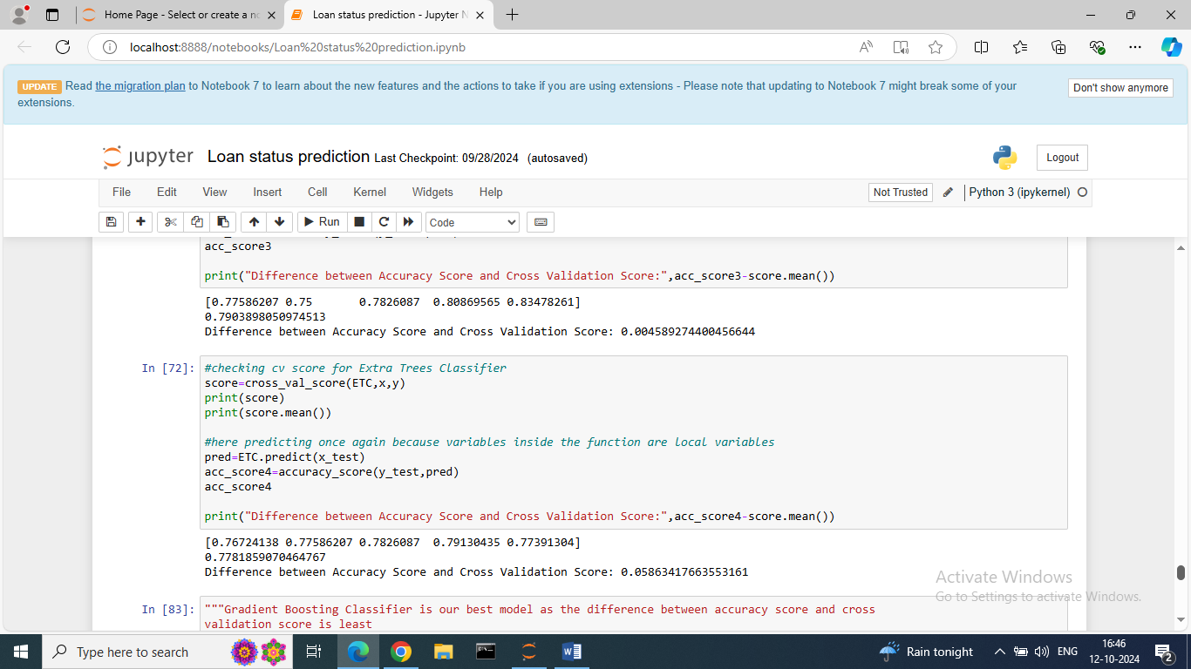

1. CV score for Gradient Boosting Classifier:

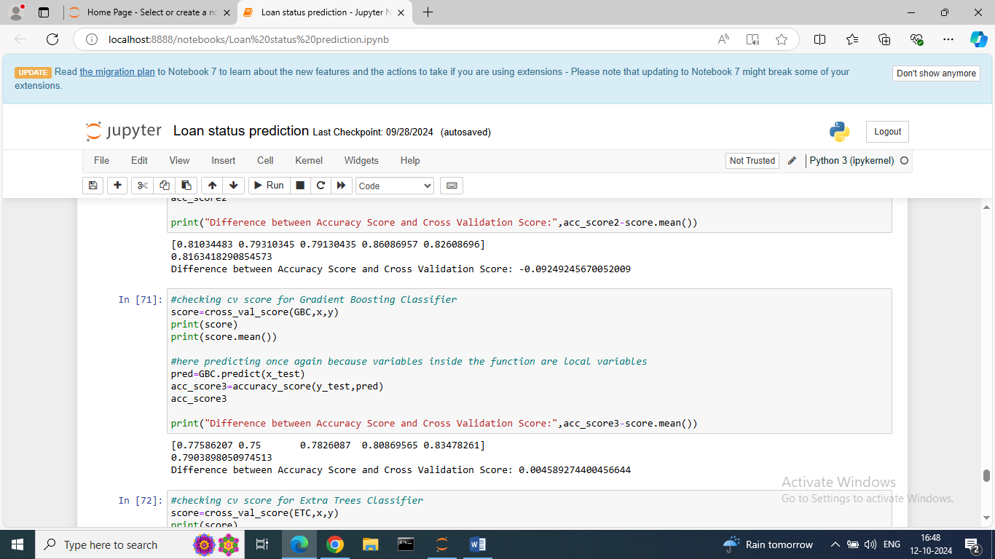

Remark:

As the difference between accuracy score and cross validation score is least “Gradient Boosting Classifier” is our best model.

Hyper parameter tuning:

 Hyper parameters are used to tune the performance of a model, and they can have a significant impact on the model’s accuracy, generalization, and other metrics.

There are several parameters for tuning they need to be adjusted by our algorithm.

Using GridSearchCV do the hyper parameter tuning.

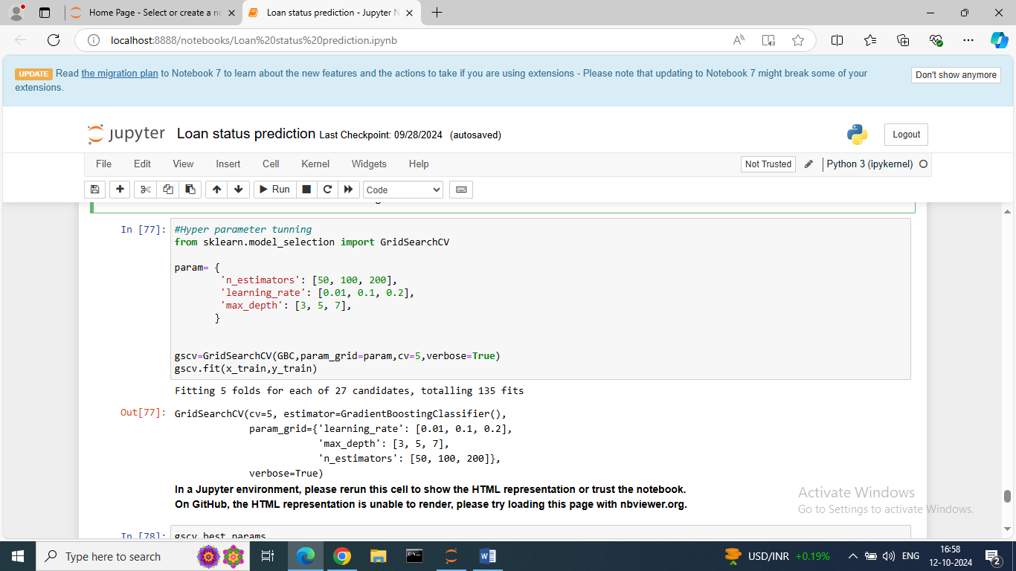

The Parameters for Gradient Boosting Classifier is n_estimators, learning rate, max depth.

Using best parameters building our Gradient Boosting Classifier model.

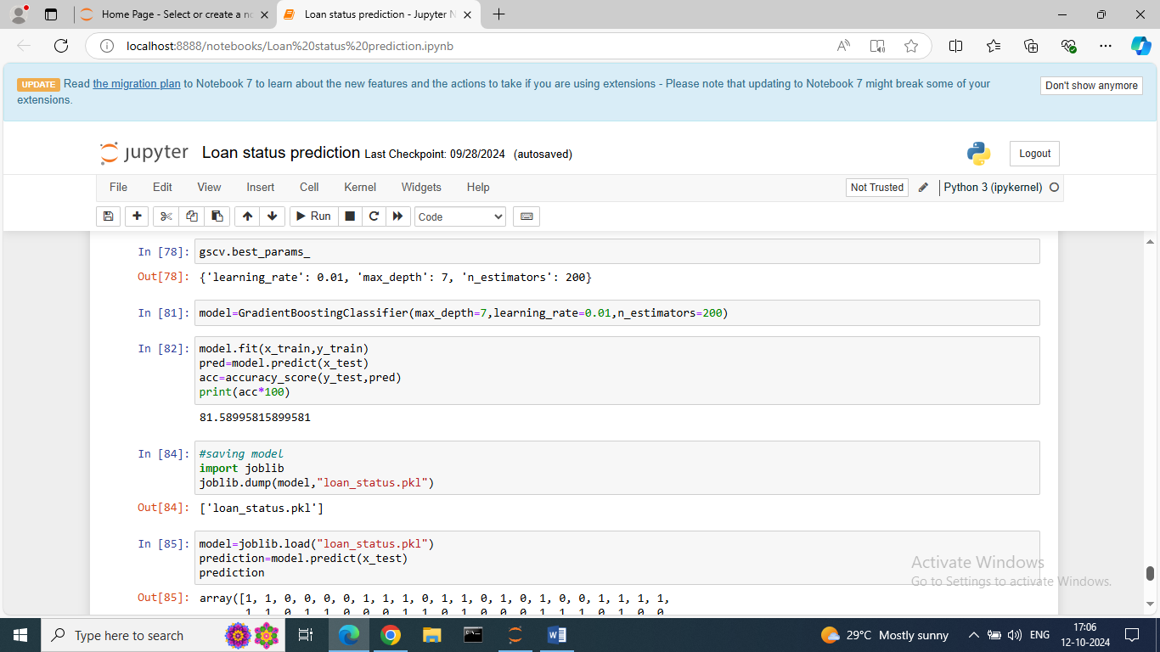

Conclusion:

“Gradient Boosting Classifier” is giving the best accuracy with an accuracy score 81.58% for prediction of Applicants approval of Loan Status.